Use mouse to select the variable that you want to rename all

Ctrl+R Ctrl+R rename it enter enter

<https://docs.microsoft.com/zh-tw/visualstudio/ide/reference/rename?view=vs-2019>

Ctrl+Shift+F(multiple fle)

find and replace what you find in certain scope

Ctrl+H(current file) typing Alt+A

find and replace all you find

comment

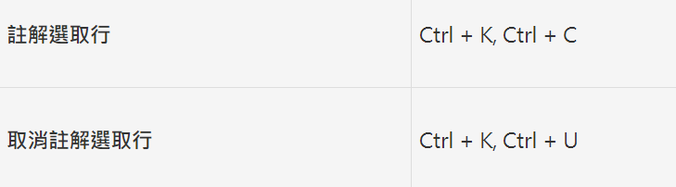

<https://dotblogs.com.tw/asdtey/2009/10/06/10924>

**先按Ctrl+F打开搜索框，然后搜索要编辑的内容，接着按Ctrl+Shift+L就可以选中对应的所有内容了，然后可以全部编辑和替换了。按了Ctrl+shift+L之后把搜索框关闭就可以同时编辑多处了。**

**此处我就是搜索items**

